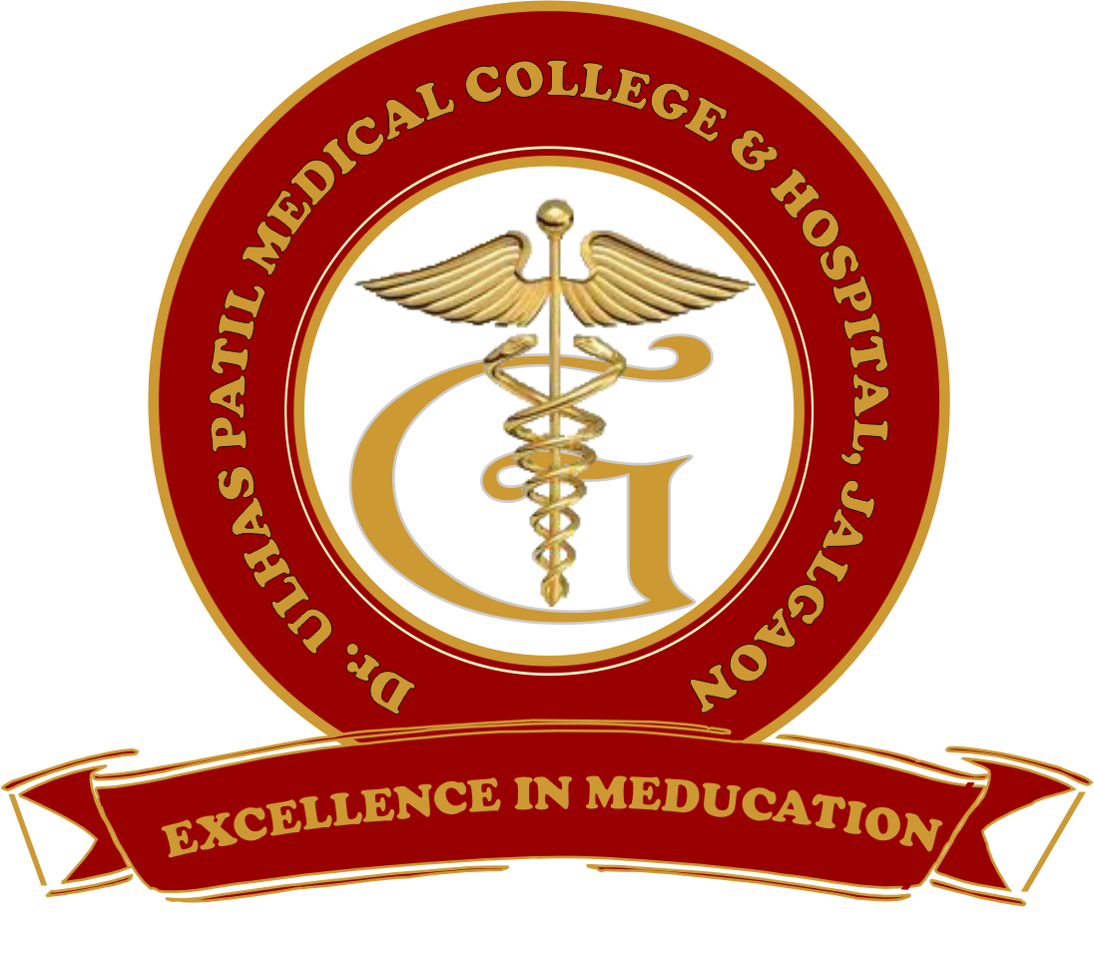 | Godavari Foundation’s  DR. ULHAS PATIL MEDICAL COLLEGE & HOSPITAL,  Recognized by Medical Council of India, Approved by Central Govt. of India, New Delhi,  Letter no. MCI-34(41)/2012-med./158127, dated 05/02/2013  Affiliated to Maharashtra University of Health Sciences, Nashik [College Code-1306]  Jalgaon-Bhusawal Road, Jalgaon Kh, Tal. & Dist. Jalgaon 425309  Tel. No. (0257)2366657, 2366678 Fax No. 0257-2366648  Email ID : dupmcj@yahoo.in Web Site : www.dupmc.ac.in
7.1.10 The Institution celebrates / organizes national and international commemorative days, events and festivals.
Describe the efforts of the Institution in celebrating /organizing National and International commemorative days and events and festivals up to 500 words.
Dr. Ulhas Patil Medical College is fully dedicated to celebrating, national and international commemorative days and events and festivals. We deeply understand hierarchical society and a lot of diversities are observed whether ethnic, linguistic, regional economic, religious, class and caste group, etc. we are celebrating very national festival of India is celebrated with patriotism and great zeal. National Festivals are a national treasure that revives our spiritual values and deep-rooted sentiments and unites us to celebrate with pride; they remind us about the sacrifice of the national leaders and freedom fighters.
With this view, we are enthusiastically celebrating all National and International commemorative days and events, and festivals with a cultural program indirectly which will reflect inside the students for developing potential their talent and building up good character discipline and personalities.
Following are the important National and International commemorative days and events and festivals that are celebrated at the institute
- Republic day 26th Jan of every year the adoption of the Indian Constitution.
- Independence day 15th Aug of every year realizing the importance of the freedom
- Gandhi Jayanti 2nd Oct of every year to value Mahatma Gandhi’s teachings of cleanliness and Ahimsa.
- Ganesh Utsav was celebrated by institute at the hostels
- Diwali festival celebrated by hospital students and nursing staff
- Cultural harmony is also observed while celebrating major cultural festivals such as Shivaji Maharaj Jayanti, Christmas, Holi, Onam Dahi Handi, Dussehra, Ganesh Chaturthi. And Eid
- With the celebration of above all events, we also celebrates the cultural events, sports, blood donation camps, and multi diagnostic health camps so students are aware of their responsibilities and also understand human rights and human value.
- TB day celebrated in each year on 24th March
- International nursing day celebrated in each year on 12th May
- Anesthesia day celebrated in each year on 17th Oct
- World psychology day celebrated in each year on 14th April
- Teachers day celebrated in each year on 5th Sept.
- National yoga day celebration on 12th Jun
- National integration day celebrated on 19th Nov

Dean Chairman
Dr Ulhas Patil Medical College, Jalgaon. Dr Ulhas Patil Medical College, Jalgaon.

